1. Start the Angular serve by to the application directory in your command prompt and typing **ng serve**

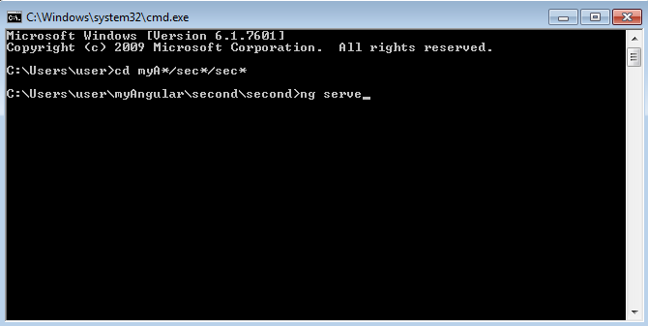

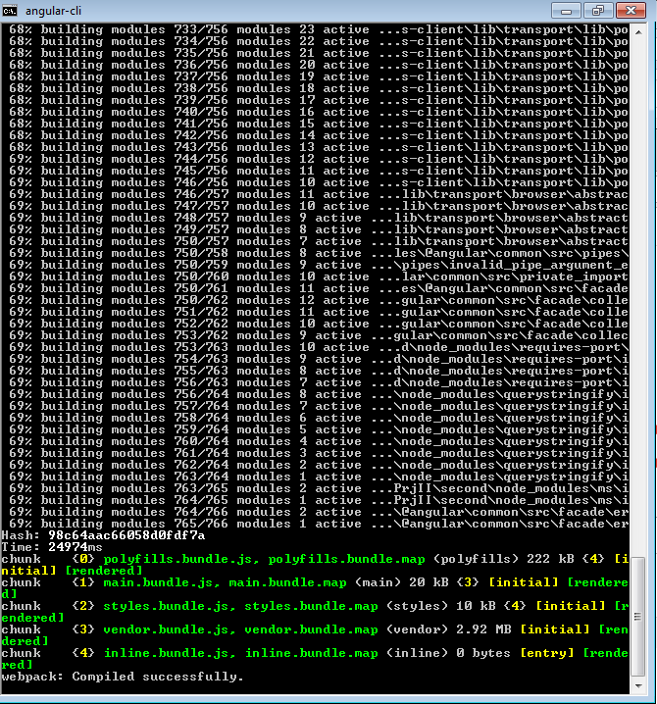

1. Launch a browser and type **localhost:4200** in the address bar

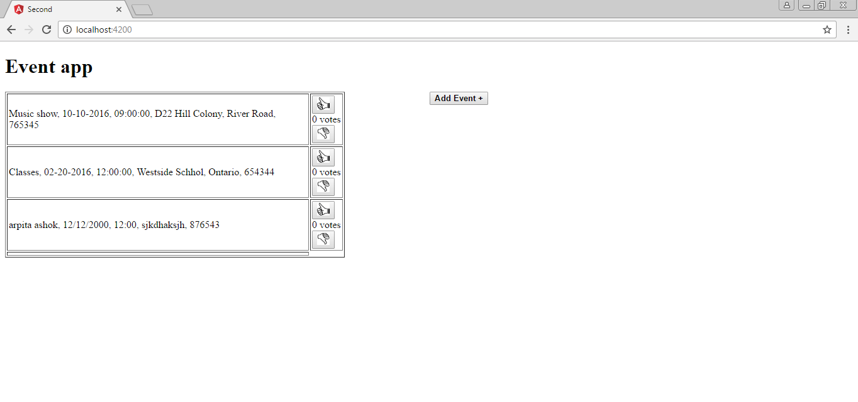

The Dashboard component (Home page) comes up

1. Click on the **Add Event** button. The following screen comes up. This is the Event component

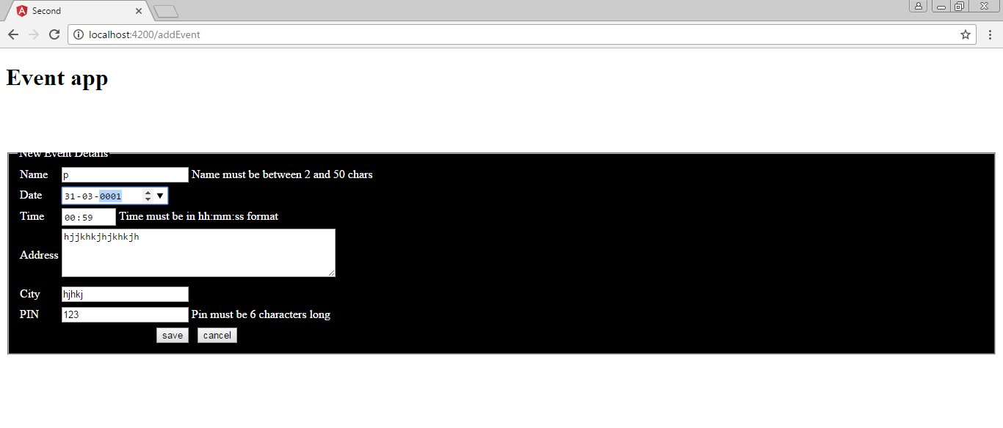5. Enter valid values in the Event component and click **Save**

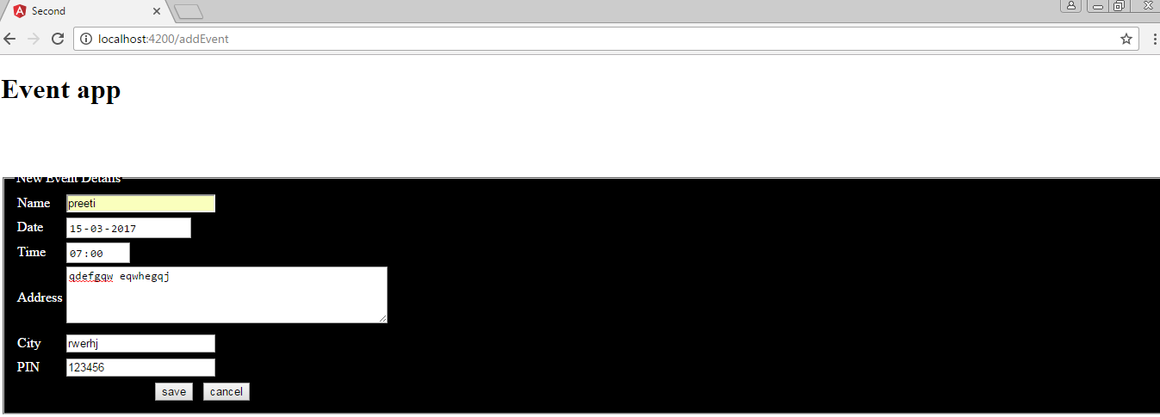

6. The dashboard page comes up with newly added event

